Homework 11: Just say something! Parent versus Peer influence on Adolescent Casual Sexual Behavior

Ryan McLean

BYU MFHD 600

Abstract

Recent evidence suggests that sexual intercourse is now a normative, and expected, part of the high school experience (Steinberg, 2007), with casual sexual experiences replacing traditional romantic relationship contexts (Elo et al., 1999). Some have theorized that this might be the case when adolescents perceive that peers are engaging in sexual activity, and then assume it is also acceptable for them (Kinsman et al., 1998). Additional research has also shown that parental factors might play a role in decreasing sexual activity (Hadley et al., 2009). Therefore, the purpose of the study was to examine the relations between the peer sexual norms and casual sexual activity, and further examine the moderating role that parents can play in weakening that association. The final sample included 1906 adolescents (21.48% 13-14; 27.99% 15-16; 50.54% 17-18) with an equal representation of each gender (50.39% male, 49.61% female), with well-distributed income (31.26% low; 46.87% middle; 21.87% high) and fairly nationally representative race (53.18% white, 14.92% African American, 13.45% Latino). Results of a moderated linear regression model suggest that the frequency of parental discussions about sex during the previous year have a significant effect at lowering adolescents’ willingness to engage in casual sex. In other words, the parents who talked more often to their adolescent children had children who were less willing to engage in casual sex, after controlling for perceived sexual activity occurring among the adolescents’ peer group. Discussion focuses on implications of the current research in understanding adolescent sexual norms and beliefs.

Homework 11: Just say something! Parent versus Peer influence on Adolescent Casual Sexual Behavior

A recent Center for Disease Control (CDC) report has reported that by age 18, approximately 67% of American adolescents report having sex (CDC, 2012). Indeed, it seems that sexual intercourse is now a normative, and expected, part of the high school experience (Steinberg, 2007). Additionally it seems that about ¾ of adolescents have their first sexual experience outside of a committed relationship. (Elo, King, & Furstenberg, 1999; Manning, Giordano, & Longmore, 2006). Perhaps one of the biggest reasons for early sexual debut and casual sexual activity among adolescents is perceived peer norms (Kinsman, Romer, Furstenberg, & Schwarz, 1998). Social domain theory (Turiel, 1983; Turiel, Hildebrandt, Wainryb, & Saltzstein, 1991) might help to explain this by posting that *if* adolescents reason that sexual activity belongs in the personal domain (“It is my choice what to do with my body”) or the social conventional domain (“Because everyone at school is doing it”), then casual sexual activity is permissible. However, many parents are worried about unsafe sexual practices among their adolescent children and seek to help their adolescents make mature sexual decisions by teaching about consequences. This research has found that when parents discuss the dangers of unsafe sex (e.g. unwanted pregnancy, STIs), they have children who engage less frequently in unsafe sexual practices (e.g., not using condoms; Hadley et al., 2009), as well as having fewer sexual partners and more conservative ideas about sex (Harris, Sutherland, & Hutchinson, 2013). Therefore, the purpose of the study is to examine the relations between the peer sexual norms and casual sexual activity, and further examine the moderating role that parents can play in weakening that association.

**Peer Sexual Norms and Casual Sexual Activity**

Social domain theory posits that when making moral decisions, individuals reason from different domains including moral, personal, and social conventional (Turiel, 1983). The moral domain is viewed for issues of right and wrong, the personal domain is viewed as pertaining to issues of personal preference/taste, and social conventional deal with issues that are arbitrarily defined rules that do not necessarily pertain to the moral or personal domains (Turiel et al., 1991). This is important to understand during adolescence because most adolescents tend to identify what they consider to be personal preferences as similar to peers but tend to agree with parents in what they identify as moral values (Laursen & Collins, 2009). The issue arises in that parents and children do not always agree about which decisions belong in each domain, which often leads to parent-child conflict during adolescence (Laursen & DeLay, 2011). I hypothesize that because peer sexual norms have been shown to be so highly correlated with adolescent sexual activity (Kinsman et al., 1998), it is possible that adolescents are engaging in increasing amounts of sexual activity because they view these decisions as pertaining to the moral or social conventional domains.

**The Moderating Role of Parents on Sexual Activity**

When parents, specifically mothers, discuss the dangers of unsafe sex (e.g. unwanted pregnancy, STIs), they have children who engage less frequently in unsafe sexual practices (e.g., not using condoms; Hadley et al., 2009), as well as having fewer sexual partners and more conservative ideas about sex (Harris, Sutherland, & Hutchinson, 2013). These findings have been replicated among African-American and Latino adolescent girls (Teitelman, Ratcliffe, & Cederbaum, 2008) and African-American college students (Hutchinson & Montgomery, 2007). Talking proactively about pregnancy, birth control, and STI’s was associated with higher age at first intercourse (Clawson, Reese-Weber, 2003), especially when the quality of the relationship and communication was high (Padilla-Walker, 2018). Additionally, children whose parents talk to them about sex are more comfortable talking about sexual topics with their partners (e.g., HIV; O’Sullivan, Dolezal, Brackis-Cott, Traeger, & Mellins, 2005), which has been shown to reduce risky sexual practices (Hutchinson & Montgomery, 2007). I hypothesize that when parents engage their adolescent children in conversations about sexuality, parents are able to change sexual decisions from the personal domain into the moral domain, and that leads adolescents to be less willing to engage casual sexual encounters. In other words, taken together, the literature suggests that parents may serve a moderating role in weakening the relation between peer influences and adolescent willingness to engage in casual sexual activity.

**The Current Study**

Taken together, the purpose of this paper is to examine the relations between the peer sexual norms and casual sexual activity, and further examine the moderating role that parents can play in weakening that association. I hypothesize that (1) the perception of more peers engaging in sexuality will predict higher adolescent willingness to engage in casual sexual activity, as shown by cross-sectional linear regression analyses, and (2) that the frequency with which mothers discuss sexual topics with their child will significantly weaken the relationship between perceived peer sexual activity and casual sex ethic.

# Methods

## Procedures

The Healthy Sexuality Project (HSP) was initiated in the winter semester of 2018 when the group started meeting to organize the initial pilot study. The main goal in the pilot was to establish quality measurement for both healthy sexuality and parent-child sex communication. We partnered with Qualtrics and agreed to a 20-minute survey from 2000 children (half boys/girls; 1/3 low income, medium, and high) aged 13-18 (one group 13-15, another 16-18). Participants were given compensation through Qualtrics, which equated to about $3 in gift cards.

## Participants

The final sample included 1906 adolescents (21.48% 13-14; 27.99% 15-16; 50.54% 17-18) with an equal representation of each gender (50.39% male, 49.61% female), with well-distributed income (31.26% low; 46.87% middle; 21.87% high) and fairly nationally representative race (53.18% white, 14.92% African American, 13.45% Latino). Although the age is not an even split among adolescents, the skewness toward older adolescents was done with the hope to include more adolescents in the sample who are more sexually active.

## Measures

**Peer Sexual Norms**. Adolescents’ peer sexual norms were assessed using one item from Van De Bongardt, De Graaf, Reitz & Deković (2014). The item was “How many of your best friends do you think have experience with intercourse?” and the response scale ranged from 1 (*none of my friends*) to 6 (*all of my friends*). Higher scores reflected having more sexually experienced friends (*M =* 2.77, SD = 1.60).

**Casual Sex Ethic.** Adolescents reported on their personal ethic of sex. Adolescents responded to one item with the stem “I am willing to hook up and have sex with someone I only recently met” on a 5-point Likert scale from 1 (*Strongly Disagree*) to 5 (*Strongly Agree*). Higher scores reflected a higher willingness to engage in casual sex (*M =* 2.06, SD = 1.26).

**Parental communication about sex.** The frequency with which parents address with their child a variety of topics related to sexuality was assessed using an adapted version of the Parent-Teen Sexual Risk Communication Scale (Hutchinson, 2007). Adolescents rated how often their parents talked about twenty topics related to sexuality in the past year using a Likert scale from 1 (*never*) to 6 (*more than once a week*), with higher scores reflecting a higher frequency of communication. Example topics included wet dreams, pornography, and how sex can be enjoyable, etc. (Mother: α = .947, *M =* 1.58, SD = 0.77; Father: α = .959, *M =* 1.32, SD = 0.64)**.**

**Parental Warmth**. Adolescents reported on parental warmth by responding to a reduced version of the Parenting Styles and Dimensions Questionnaire (PSDQ; Robinson, Mandleco, Olsen, & Hart, 2001). Three items assessed parental warmth. Respondents rated how often various warm behaviors were exhibited by the parent using a Likert scale of 1 (*never*) to 5 (*always*), with higher scores reflecting higher parental warmth. Adolescents responded to the statements with regards to both parents separately, and for this analysis the parent’s responses were combined. A sample parental warmth item includes “My parent gives comfort and understanding when I am upset (Mother**:** α = .883, *M =* 3.58, SD = 1.26**;** Father**:** α = .89, *M =* 3.23, SD = 1.31)

**Importance of Religion.** Adolescents responded to one item with the stem “Please state how important religion is to you” on a 5-point Likert scale from 1 (*Not at all important*) to 5 (*Very important*). Higher scores reflected a higher importance of religion (*M =* 3.02, SD = 1.38).

**Demographics Variables.** Demographic variables included household income 5-point Likert scale from 1 (*My family has much less money than other families*)to 5 (*My family has much more money than other families*; *M =* 2.89, SD = 0.86), Race (53.18% white =1, 46.82% non-white=0), child age (*M =* 16.19, SD = 1.71), and biological sex assigned at birth (49.61% female = 1, 50.39% male = 0).

## Analytic Strategy

For this analysis, I will be running an OLS regression to see the predictive power of related variables. I will also include an interaction term to see if the relationship between the independent and dependent variables changes as a function of how often mothers discuss sexual topics with their adolescents.

# Results

**Assumptions**

**Normality and Linearity.** I tested for normality by looking at a histogram of adolescents’ casual sex ethic (see figure 1), and the data look approximately normal. The distribution also has a skewness factor of .863 and a Kurtosis level of 2.524 which suggest normality. To assess linearity between the primary dependent (casual sex ethic) and independent variable (perceived peer sexual norms), I examined a scatter-plot (see figure 2) and a linear relationship did exist and visually appeared to be non-zero. I also assessed non-linearity by running a preliminary regression model using a squared-term of perceived peer sexual norms and the interaction was nonsignificant (*B* = -.012, *t* = -.43, *p*-value = .666), so I did not include this term in my final model. Based on these results, I assume that my data are approximately normal and the relationship between my dependent and independent variable is approximately linear.

**Multi-Collinearity.** After running the regression, the VIF command in Stata 15 was used to determine collinearity. Maternal communication about sexual topics had a VIF of 9.93 which suggests a possible collinearity problem (typical practice keeps these values below 10). Upon further analysis of the correlation matrix (see table 2), the correlation between age and maternal communication is relatively high (r=.45, *p*<.001). This would suggest that as adolescents get older, mothers tend to engage in more communication because they believe that their adolescents are engaging in higher levels of sexual activity, which is supported by previous research (Beckett et al., 2010). Because this trend is backed up by previous research and theory, I will proceed with the analysis, though it should be noted that these results should be interpreted with caution and may not be applicable to other samples and populations.

**Heteroskedasticity.** Using White’s test, I found evidence to suggest that my model includes heteroskedasticity (χ2=176.49, df = 51, *p*<.001). I also ran a Breusch-Pagan which similarly suggested heteroskedasticity (χ2=92.51, *p*<.001). As a result of both of these tests, I ran a follow up analysis using Glesjer’s test which suggests that peer beliefs (*p* < .001), father warmth (*p* < .001), religious importance (*p* < .001), income (*p*=.044), race (*p*=.011), and gender (*p*<.001), may be leading to heteroskedasticity in my model. For this reason, I will include a “robust” option in my regression analysis in Stata 15 to account for this potential error.

**Auto-Correlation.** This assumption deals with the correlations of the error terms when dealing with time-related variables. This assumption is usually violated when dealing with longitudinal data or with data across different time points. Because this analysis is cross-sectional and I am not dealing with any other time-related variables, I do not need to test for violations of this assumption. If I did need to test for violations of this assumption, I would use the Durban-Watson test to examine and remove variation associated with adjacent measures and then run a Prais-Winsten regression to correct for that association.

**Tests for Influential Observations.** I ran three tests to identify influential observations in my regression analysis and the results can be seen in Table 3. The first was studentized residuals. This test calculates the studentized (i.e., jackknifed) residuals. In the model shown, I removed all observations that had a value greater than 3.5; no observations met this criteria. The second test calculated the Cook’s D influence statistic and compared each value to the ideal value and removed the observation; there were 92 observations which met this criteria. The third was the Dffits tests was also conducted to test for influential observations; there were 111 observations which met this criteria. As seen in Table 3, although there are multiple observations that suggest influential observations, the trend of the data was not significantly changed. The exception to this is that for the Dffits and Cook’s D, paternal warmth loses its significance. The *p*-values here range from .047 to .055 (Cook’s D) and .072 (Dffits). Although these are important considerations, I decided to move forward without removing influential observations because in the moderated model, which is more salient to the current study, paternal warmth also lost its significance. However, the reader should be aware, that some of these results should be interpreted with caution, and future studies should explore these potential influential observations and their effect on the relations described in this study.

**Peer Sexual Norms and Casual Sexual Activity**

Table 1 shows descriptive statistics for the data. To examine whether one’s perception of peer sexual activity was a significant predictor of adolescents’ willingness to engage in casual sex, I ran an OLS regression, results can be seen in table 4. The overall model had significant model fit (*F* (10, 1895) = 41.13, *p* < .001, *R2* = .1671) meaning that approximately 16.7% of the variance in an individual’s casual sex ethic can be explained by the variables in the model. This *p*-value signifies that assuming the model was no better than chance, I would expect to see a model that explained 16.7% of the variance or more, less than one time out of 1000. Peer sexual beliefs were a significant predictor of casual sexual ethic (β=0.255, *t* = 10.18, *p* < .001). This means that for every one standard deviation increase in an adolescent believing one’s peers are sexual active, I would expect to see a corresponding .255 standard deviation increase in an individual’s willingness to engage in casual sex, after controlling for all other variables in the model. This *p*-value signifies that, assuming there is no linear relationship between peer sexual beliefs and casual sexual ethic in the population, I would expect to see a slope of β=.255 or something further from zero, less than 1 time out of 1000. Mother communication was not a significant predictor of casual sex ethic (β= .013, *p* = .705), after controlling for all other variables in the model. Other parenting factors were also nonsignificant, such as father communication (β= .001, *p* = .983), maternal warmth (β= .010, *p* = .708), and paternal warmth (β= -.053, *p* = .053), after controlling for all other variables in the model. In addition, religious importance was a significant predictor (β= -.148, *t* = -6.77, *p* < .001), meaning that for every one standard deviation increase in feeling that religion is important is associated with a .148 lower willingness to engage in casual sex, after controlling for all other variables in the model. Race was a significant predictor (*B* = -.12, β= -.048, *t* = -2.23, *p*-value = .026) meaning that on average white adolescents report -.12 units less casual ethic when compared to non-white adolescents. Females also tend to report .77 units less casual sexual ethic than males (*B* = -.77, β= -.307, *t* = -13.35, *p* < .001). Household income (β= .042, *p*-value = .08), and age (β= .019, *p*-value = .424) were non-significant predictors.

**The Moderating Role of Parents on Sexual Activity**

To further examine whether one’s perception of peer sexual activity was a significant predictor of adolescents’ willingness to engage in casual sex changed based on the frequency of maternal communication, I ran the above OLS regression with an additional interaction term of frequency of maternal communication about sexual topics, results can be seen in table 5. The overall model had significant model fit (*F* (11, 1894) = 37.87, *p* < .001, *R2* = .1704) meaning that approximately 17% of the variance in an individual’s casual sex ethic can be explained by the variables in the model. This *p*-value signifies that assuming the model is no better than chance, I would expect to see a model that explained 17% of the variance or more less than one time out of 1000. Peer sexual beliefs were a significant predictor of casual sexual ethic (β=0.378, *t* = 6.80, *p* < .001); this means that for every one standard deviation increase in an adolescent believing one’s peers are sexual active, I would expect to see a corresponding .378 standard deviation increase in an individual’s willingness to engage in casual sex, after controlling for all other variables in the model. This *p*-value signifies that, assuming there is no linear relationship between peer sexual beliefs and casual sexual ethic in the population, I would expect to see a slope of β=.378 or something further from zero, less than 1 time out of 1000. The interaction between maternal communication about sexual topics and adolescents’ peer sexual beliefs was significant (β= -.181, *t* = -2.57, *p*-value = .01) meaning that I expect that the effect of perceived peer sexual activity on whether an individual is willing to engage in casual sex to change decrease by .18 for every one standard deviation increase in how often parents talk about sexuality in the home. Additional follow-up analyses suggest that there is a relationship between peer norms and casual sex ethic when parents talk never (*p*< .001), once (*p*< .001), or 2-3 times (*p*= .004) in the last year, but that relationship becomes nonsignificant when parents talk once a month (*p*=.424), once a week (*p=*.874), or more than once a week (*p*=.484; see Figure 4 for visual representation of moderation and Table 6). Other parenting factors were nonsignificant, such as father communication (*p* = .819), maternal warmth (*p* = .736), and paternal warmth (*p* = .055), after controlling for all other variables in the model. Although paternal warmth did not reach the standard cutoff of *p*<.05, I believe the resultant *p*-value of .055 is worthy of future exploration, particularly because it is so much lower than the value for maternal warmth, see discussion for conceptual explanation of these results. In addition, religious importance was a significant predictor (β= -.15, *t* = -6.78, *p* < .001), meaning that for every one standard deviation increase in feeling that religion is important is associated with a .15 lower willingness to engage in casual sex, after controlling for all other variables in the model. Race was a significant predictor (*B* = -11, β= -.044, *t* = -2.08, *p*-value = .038) meaning that on average white adolescents report -.11 units less casual ethic than non-whites. Females also tend to report .788 units less casual sexual ethic than men (*B* = -.78, β= -.309, *t* = -13.52, *p* < .001). Household income (β= .042, *p*-value = .094), and age (β= .017, *p*-value = .477) were non-significant predictors.

# Discussion

In this study, I ran two regression models to understand the relationship between perceived peer sexual norms and willing to engage in casual sexual activity and explored the power that parents might have to attenuate the power of peer pressure in their adolescent’s lives. I found that there was a significant association between peer sexual norms and casual sexual ethic, and further analysis suggests that that relation could be weakened as the frequency of parent-child discussions about sexuality increased.

**Peer Sexual Norms and Casual Sexual Activity**

My first hypothesis was supported in that initial results showed that there was a strong relationship between perceived peer sexual norms and casual sex ethic, which is consistent with previous research (Kinsman et al., 1998). One reason that these two variables might be related can be viewed through social domain theory (Turiel, 1983). Social domain theory would hypothesize that when adolescents view their sexual activity as pertaining to the moral or social convention domains, they will engage in more sexual activity because their peers are similarly engaging or because it is personally rewarding (Kinsman et al., 1998)

**The Moderating Role of Parents on Sexual Activity**

In addition, my second hypothesis was supported meaning that the relation between whether an individual believed that peers were engaging in sex and whether one was willing to engage in casual sex was significantly moderated by frequency of parent communication, while also controlling for how often the father talked about sex, as well as maternal and paternal warmth. My models suggest that the power of peer pressure in adolescents’ willingness to engage in casual sex is attenuated each time they engage in conversation with their mother about sexual topics, until the relation disappears completely when parents talk once a month or more. Social domain theorizing helps to understand by suggesting that when parents frequently engage in discussions about sexuality, they are able to impress upon their adolescents the importance of viewing sexuality as a value (i.e., the moral domain) instead of a personal preference or social convention. Because adolescent values tend to match parental values (Laursen & Collins, 2009), this would explain why frequent maternal discussions about sexuality weaken the relation between peer sexual norms and casual sexual ethic.

**Future Research and Implications**

In addition, my analysis showed a potential for future research. Previous research has found that parent-child relationship quality might be a critical component of these sexuality conversations (Sneed et al., 2013). Unfortunately, my results did not support this. However, paternal warmth was significant at the level of a trend (*p*=.055). This is of particular note because the *p*-value for maternal warmth was *p*=.736, which is vastly different. Because of this, future research should examine paternal warmth as being a key factor in the effectiveness of these conversations. The relation between peer sexual activity and casual sex ethic existed when mothers did not talk about sex and relationship quality with dad was poor. This leads me to hypothesize that mothers and fathers both matter, but they matter for different reasons. In other words, mothers matter more for the content of the conversations, and fathers matters more as a secure relationship base that helps adolescents feel safe at home, but more research is needed.

This research also has significant limitations. It is an Ordinary Least Squares regression model, which cannot explore mediational relationships, so analytically understanding the mechanisms explaining the relations is impossible. This analysis was also done on a cross-sectional sample, so endogeneity cannot be determined. It is very possible that there are certain person characteristics, which influence and cause this relation to exist, but the current sample does not support this level of analysis. Additionally, because this research question is inherently developmental, there might be individual variation which explains more about this relationship than simple averages. Future research should use person-centered analysis to examine these relations and find trajectories and profiles of individuals. Understanding these factors would enable practitioners to design more effective interventions to help adolescents and parents work through their sexual identity development and values.

This study aimed to examine the relations between peer pressure and casual sexual ethic and the potential the mothers have to attenuate that relation. My data suggest that it is not as important what mothers are saying, their children just want them to engage in conversations frequently. Perhaps if parents engage in frequent, proactive conversations about sexuality (Rogers, Ha, Stormshak, & Dishion, 2015), they can reduce the effect of peer pressure on sexual activity and potentially protect their children from the negative outcomes of casual and risky sexual activity such as sexually-transmitted disease or sexual assault. Parents, for the love of your children, just say something! I believe that your hormonal teenagers are listening.

# References

Beckett, M. K., Elliott, M. N., Martino, S., Kanouse, D. E., Corona, R., Klein, D. J., & Schuster, M. A. (2010). Timing of parent and child communication about sexuality relative to children’s sexual behaviors. Pediatrics, 125(1), 34–42. doi:10.1542/peds.2009-0806

Elo, I. T., King, R. B., & Furstenberg, F. F. Jr. (1999). Adolescent females: Their sexual partners and the fathers of their children. *Journal of Marriage and the Family*, *61*(1), 74–84. https://doi.org/10.2307/353884

Fasula, A. M., & Miller, K. S. (2006). African-American and Hispanic adolescents’ intentions to delay first intercourse: Parental communication as a buffer for sexually active peers. Journal of Adolescent Health, 38(3), 193–200. doi:10.1016/j.jadohealth.2004.12.009

Guilamo-Ramos, V., Jaccard, J., Dittus, P., & Collins, S. (2008). Parent– adolescent communication about sexual intercourse: An analysis of maternal reluctance to communicate. Health Psychology, 27(6), 760–769. doi:10.1037/a0013833

Hadley, W., Brown, L. K., Lescano, C. M., Kell, H., Spalding, K., Diclemente, R., & Donenberg, G. (2009). Parent–adolescent sexual communication: Associations of condom use with condom discussions. AIDS and Behavior, 13(5), 997–1004. doi:10.1007/s10461-008-9468-z

Halpern-Felsher, B. L., Kropp, R. Y., Boyer, C. B., Tschann, J. M., & Ellen, J. M. (2004). Adolescents’ self-efficacy to communicate about sex: Its role in condom attitudes, commitment, and use. Adolescence, 9(155), 443–456.

Harris, A. L., Sutherland, M. A., & Hutchinson, M. K. (2013). Parental influences of sexual risk among urban African American adolescent males. Journal of Nursing Scholarship, 45(2), 141–150. doi:10.1111/jnu.12016

Hutchinson, M. K., & Montgomery, A. J. (2007). Parent communication and sexual risk among African Americans. Western Journal of Nursing Research, 29(6), 691–707. doi:10.1177/0193945906297374

Kapungu, C. T., Baptiste, D., Holbeck, G., McBride, C., Robinson-Brown, M., Sturdivant, A., … Paikoff, R. (2010). Beyond the “birds and the bees”: Gender differences in sex-related communication among urban African-American adolescents. Family Process, 49(2), 251–264. doi:10.1111/j.1545-5300.2010.01321.x

Kinsman, S. B., Romer, D., Furstenberg, F. F., & Schwarz, D. F. (1998). Early Sexual Initiation: The Role of Peer Norms. *Pediatrics*, *102*(5), 1185–1192. <https://doi.org/10.1542/peds.102.5.1185>

Laursen, B., & Collins, W. A. (2009). Parent—child relationships during adolescence. *Handbook of adolescent psychology*, *2*.

Laursen, B., & DeLay, D. (2011). Parent-child relationship. *Encyclopedia of Adolescence*, *2*, 233–240.

Manning, W. D., Giordano, P. C., & Longmore, M. A. (2006). Hooking Up: The Relationship Contexts of “Nonrelationship” Sex. *Journal of Adolescent Research*, *21*(5), 459–483. https://doi.org/10.1177/0743558406291692

Padilla-Walker, L. M. (2018). Longitudinal change in parent-adolescent communication about sexuality. Journal of Adolescent Health

Peterson, S. H. (2007). The importance of fathers: Contextualizing sexual risk-taking in “low-risk” African American adolescent girls. Journal of Human Behavior in the Social Environment, 15(2–3), 329–346. doi:10.1300/J137v15n02_19

Rogers, A. A., Ha, T., Stormshak, E. A., & Dishion, T. J. (2015). Quality of parent–adolescent conversations about sex and adolescent sexual behavior: An observational study. Journal of Adolescent Health, 57(2), 174–178. https://doi.org/10.1016/j.jadohealth.2015.04.010

Sneed, C. (2008). Parent–adolescent communication about sex: The impact of content and comfort on adolescent sexual behavior. Journal of HIV/AIDS Prevention in Children and Youth, 9(1), 70–83. doi:10.1080/10698370802126477

Sneed, C., Somoza, C. G., Jones, T., & Alfaro, S. (2013). Topics discussed with mothers and fathers for parent–child sex communication among African-American adolescents. Sex Education, 13(4), 450–458. doi:10.1080/14681811.2012.757548

Teitelman, A. M., Ratcliffe, S. J., & Cederbaum, J. A. (2008). Parent–adolescent communication about sexual pressure, maternal norms about relationship power, and STI/HIV protective behaviors of minority urban girls. Journal of the American Psychiatric Nurses Association, 14(1), 50–60. doi:10.1177/1078390307311770

Turiel, E. (1983). *The development of social knowledge: Morality and convention*. Cambridge University Press.

Turiel, E., Hildebrandt, C., Wainryb, C., & Saltzstein, H. D. (1991). Judging Social Issues: Difficulties, Inconsistencies, and Consistencies. *Monographs of the Society for Research in Child Development*, *56*(2), i. https://doi.org/10.2307/1166056

Widman, L., Noar, S. M., Choukas-Bradley, S., & Francis, D. B. (2014). Adolescent sexual health communication and condom use: A meta-analysis. Health Psychology, 33(10), 1113–1124. <https://doi.org/10.1037/hea0000112>

# Tables and Figures

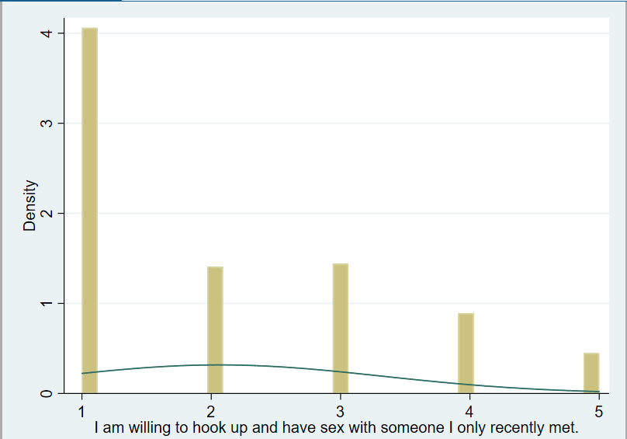

Figure 1. Histogram of dependent variable

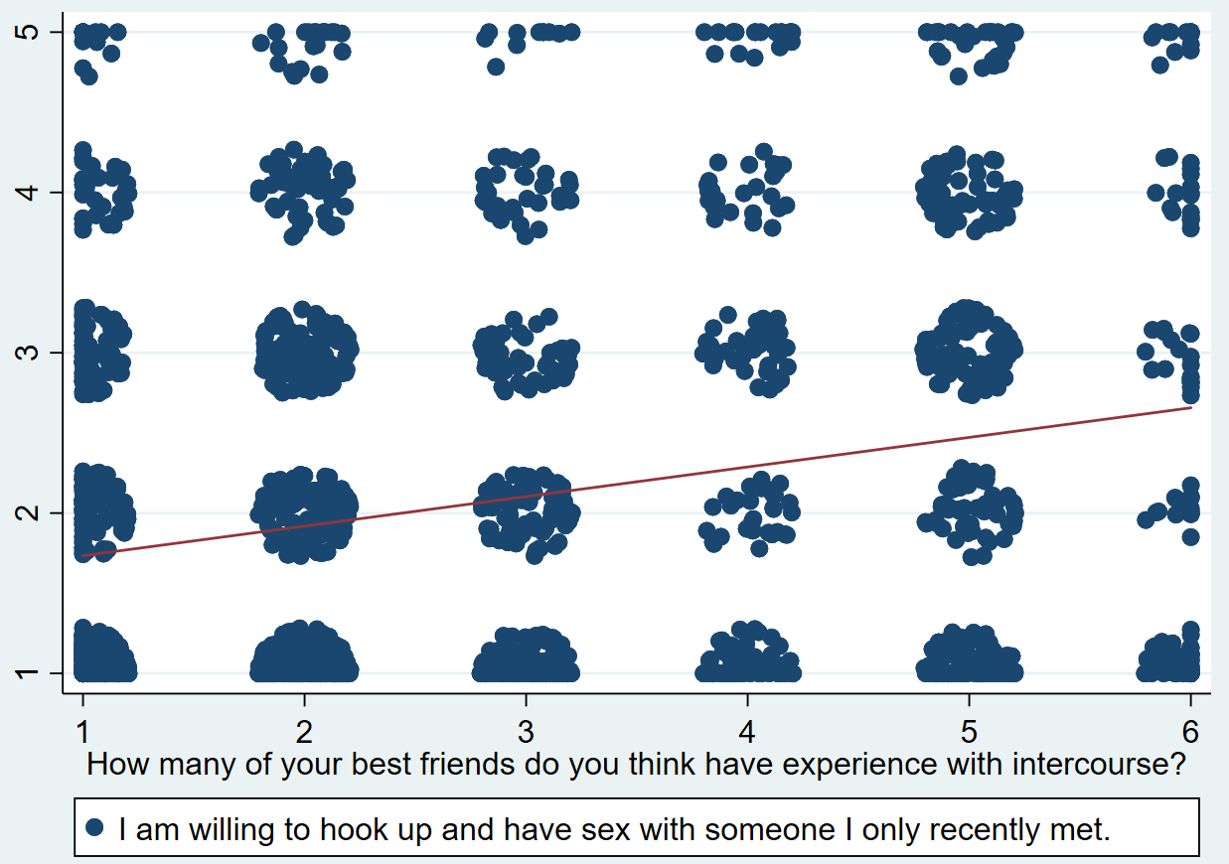

Figure 2. Scatterplot showing the relationship between dependent variable and main outcome variable.

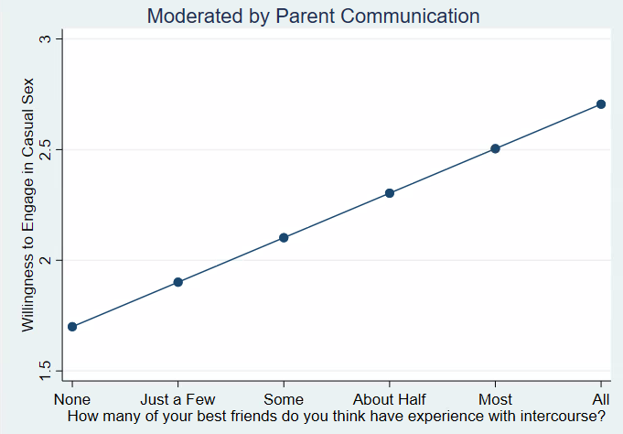

Figure 3. Visual representation of the relationship between adolescents’ beliefs about sexual behavior and willingness to engage in sex with a stranger.

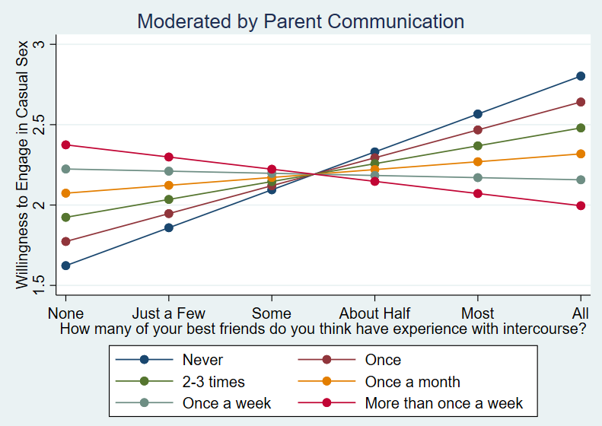

Figure 4. Visual representation of the relationship between adolescents’ beliefs about sexual behavior and willingness to engage in sex with a stranger, moderated by levels of parent communication.

**Tables and Figures**

|  |  |  |  |  |
| --- | --- | --- | --- | --- |
|  | Mean | Standard Deviation | Minimum | Maximum |
| I am willing to hook up and have sex with someone I only recently met. | 2.06 | 1.26 | 1 | 5 |
| How many of your best friends do you think have experience with intercourse? | 2.78 | 1.60 | 1 | 6 |
| How often, in the past year, has your mother talked about sexual topics? | 1.58 | 0.77 | 1 | 6 |
| How often, in the past year, has your father talked about sexual topics? | 1.32 | 0.64 | 1 | 5.35 |
| Maternal Warmth | 3.58 | 1.26 | 1 | 5 |
| Paternal Warmth | 3.23 | 1.31 | 1 | 5 |
| Please state how important religion is to you | 3.02 | 1.38 | 1 | 5 |
| Compared to other families, how would you say yours compares? | 2.89 | 0.86 | 1 | 5 |
| How old are you in years? | 16.19 | 1.71 | 13 | 18 |

*Table 1. Descriptive Statistics for Analysis Variables*

*Table 2. Correlations between all analysis variables*

|  |  |  |  |  |  |  |  |  |  |  |
| --- | --- | --- | --- | --- | --- | --- | --- | --- | --- | --- |
|  | 1 | 2 | 3 | 4 | 5 | 6 | 7 | 8 | 9 | 10 |
| 1. I am willing to hook up and have sex with someone I only recently met. | -- |  |  |  |  |  |  |  |  |  |
| 2. How many of your best friends do you think have experience with intercourse? | .23  *** | -- |  |  |  |  |  |  |  |  |
| 3. How often in the past year has your mother talked about sexual topics? | -.01 | .10  *** | -- |  |  |  |  |  |  |  |
| 4. How often in the past year has your father talked about sexual topics? | .04 | .05  * | .67  *** | -- |  |  |  |  |  |  |
| 5. Maternal Warmth | -.02 | -.08  *** | .19  *** | .11  *** | -- |  |  |  |  |  |
| 6. Paternal Warmth | -.04 | -.07  ** | .10  *** | .22  *** | .59  *** | -- |  |  |  |  |
| 7. Please state how important religion is to you | -.16  *** | -.05  * | .07  ** | .06  * | .15  *** | .10  *** | -- |  |  |  |
| 8. Income | .04 | -.08  *** | .02 | .12  *** | .15  *** | .17  *** | .05  * | -- |  |  |
| 9. Race (white = 1, nonwhite = 0) | .02 | .11  *** | -.06  ** | -.05  * | .10  *** | .06  * | -.08  *** | .04 | -- |  |
| 10. Gender (female = 1, male = 0) | -.27  *** | .11  *** | .15  *** | -.09  *** | -.12  *** | -.12  *** | 0 | -.14  *** | -.08  *** | -- |
| 11. Age | .06  ** | .45  *** | .03 | 0 | -.06  ** | -.06  ** | 0 | -.08  *** | .04 | .21  *** |

* *p* < 0.05, ** *p* < 0.01, *** *p* < 0.001

*Table 3. Regression models to determine influential observations*

|  |  |  |  |  |
| --- | --- | --- | --- | --- |
|  | Normal | Dffits | Cook's D | Studentized Residuals |
| How many of your best friends do you think have experience with intercourse? (Peer) | 0.20*** | 0.21*** | 0.21*** | 0.20*** |
| How often, in the past year, has your mother talked about sexual topics? (Communication) | 0.02 | -0.02 | -0.01 | 0.02 |
| How often, in the past year, has your father talked about sexual topics? | 0.00 | 0.03 | 0.03 | 0.00 |
| Maternal Warmth | 0.01 | 0.02 | 0.01 | 0.01 |
| Paternal Warmth | -0.05* | -0.04 | -0.05 | -0.05* |
| Please state how important religion is to you | -0.14*** | -0.13*** | -0.14*** | -0.14*** |
| Income | 0.06 | 0.07* | 0.07* | 0.06 |
| Race (white = 1, non-white = 0) | -0.12* | -0.11* | -0.1 | -0.12* |
| How old are you in years? | -0.77*** | -0.77*** | -0.77*** | -0.77*** |
| Gender (female=1, male = 0) | 0.01 | 0.01 | 0.01 | 0.01 |
| Constant | 2.04*** | 1.86*** | 1.92*** | 2.04*** |
| N | 1906 | 1795 | 1814 | 1906 |
| * p<0.05, **p<0.01, *** p<0.001 |  |  |  |  |

*Table 4. Regression model predicting whether an individual is willing to engage in sex with a recent acquaintance.*

|  |  |  |  |
| --- | --- | --- | --- |
|  | B | Beta | Standard  Error |
| How many of your best friends do you think have experience with intercourse? (Peer) | 0.20*** | 0.25*** | 0.02 |
| How often, in the past year, has your mother talked about sexual topics? (Communication) | 0.02 | 0.01 | 0.06 |
| How often, in the past year, has your father talked about sexual topics? | 0.00 | 0.00 | 0.06 |
| Maternal Warmth | 0.01 | 0.01 | 0.03 |
| Paternal Warmth | -0.05 | -0.05 | 0.03 |
| Please state how important religion is to you | -0.13*** | -0.15*** | 0.02 |
| Income | 0.06 | 0.04 | 0.04 |
| Race (white = 1, non-white = 0) | -0.12* | -0.05* | 0.05 |
| How old are you in years? | -0.77*** | -0.31*** | 0.06 |
| Gender (female=1, male = 0) | 0.01 | 0.02 | 0.02 |
| Constant | 2.04 | -- | 0.30 |
| R2 | .1671 |  |  |
| F-test (10, 1895) | 41.13*** |  |  |
| Number of Observations | 1,906 |  |  |

* *p* < 0.05, ** *p* < 0.01, *** *p* < 0.001

*Table 5. Regression model predicting whether an individual is willing to engage in sex with a recent acquaintance including moderation term*

|  |  |  |  |
| --- | --- | --- | --- |
|  | B | Beta | Standard  Error |
| How many of your best friends do you think have experience with intercourse? (Peer) | 0.30*** | 0.38*** | 0.04 |
| How often, in the past year, has your mother talked about sexual topics? (Communication) | 0.21** | 0.13** | 0.09 |
| Peer x Communication | -0.06* | -0.18* | 0.02 |
| How often, in the past year, has your father talked about sexual topics? | -0.01 | -0.01 | 0.06 |
| Maternal Warmth | 0.01 | 0.01 | 0.03 |
| Paternal Warmth | -0.05 | -0.05 | 0.03 |
| Please state how important religion is to you | -0.13*** | -0.15*** | 0.02 |
| Income | 0.06 | 0.04 | 0.04 |
| Race (white = 1, non-white = 0) | -0.11* | -0.04* | 0.05 |
| How old are you in years? | -0.78*** | -0.31*** | 0.06 |
| Gender (female=1, male = 0) | 0.01 | 0.02 | 0.02 |
| Constant | 1.80 | -- | 0.31 |
| R2 | .1704 |  |  |
| F-test (11, 1894) | 37.87*** |  |  |

* *p* < 0.05, ** *p* < 0.01, *** *p* < 0.001

*Table 6. Table showing the simple slope analysis showing the moderating impact of maternal communication about sexual topics in the last year on the relation between peer sexual norms and casual sex ethic*

|  |  |
| --- | --- |
|  | Slope |
| Never | 0.235*** |
| Once | 0.174*** |
| 2-3 Times | .111** |
| About Once a Month | .049 |
| Once a Week | -.013 |
| More than Once a Week | -.076 |

* *p* < 0.05, ** *p* < 0.01, *** *p* < 0.001